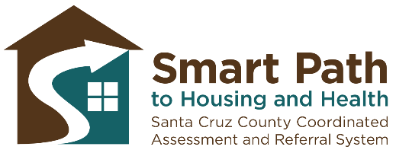
Smart Path to Housing and Health
Talking Points for Service Providers

    - If you are experiencing homelessness in Santa Cruz County and looking for a permanent place to call home, the first step is to take the Smart Path Assessment to be considered for multiple housing programs countywide.

    - We have created a new process in Santa Cruz County called Smart Path for Housing and Health that can help you access services more easily and efficiently.

    - This is not an assessment for a specific program, but rather a way of getting your information so you will be considered for many programs and services. Think of it like going to get an ID, it doesn’t guarantee you any services, but it’s the first step you need to take to be considered for opportunities.

    - Through this assessment, you will be considered for services from agencies all across the county, not just [agency name].

    - At this point, we are including Permanent Supportive Housing, Rapid Rehousing, and Transitional Housing in our system, which are all long-term housing options, not simply shelters.

    - The Smart Path Assessment enables providers to fairly and uniformly provide resources to those in need based on level of need and available housing resources.

    - After completing the Assessment, you may be contacted if there is a housing program match available that meets your household’s needs.

    - Completing an Assessment is not a guarantee of housing or shelter.

    - Here is a list of Access Points where you can complete the Assessment. (Make sure to carry printed copies of latest Access Points document, available on SmartPathScc.org). You can learn more at smartpathscc.org.

    - If you have already taken a VI-SPDAT survey or Smart Path Assessment within the last year, then your information is already included in the coordinated entry system Participant List and you will be considered for potential housing opportunities.

- You are encouraged to contact the Smart Path Referral Specialist if:
  - You need to update your contact information, or;
  - You have experienced a life-changing event, such as
      - Having minor children join the household
      - A significant change in your health status
      - Being diagnosed with a chronic illness or disability
      - You are no longer interested in being considered for housing
  - Here is her contact information: Monica Lippi, Smart Path Referral Specialist Phone: 831-454-4108 and Email: Smart.Path@SantaCruzCounty.us

